САНКТ-ПЕТЕРГБУРГСКИЙ НАЦИОНАЛЬНЫЙ ИССЛЕДОВАТЕЛЬСКИЙ УНИВЕРСИТЕТ

ИНФОРМАЦИОННЫХ ТЕХНОЛОГИЙ, МЕХАНИКИ И ОПТИКИ

Курсовая работа по дискретной математике

Вариант 40

Выполнил: Назирджанов Некруз Фарходович

Группа: P3110

Санкт-Петербург

2021 г.

|  |  |
| --- | --- |
| f = 1 | f = d |
| 9 ≤ 1X4X5 + X1X2X3 < 12 | |X5X1X2 - X4X3 |= 0 |

|  |  |  |  |  |  |  |  |  |  |  |  |  |  |  |  |  |
| --- | --- | --- | --- | --- | --- | --- | --- | --- | --- | --- | --- | --- | --- | --- | --- | --- |
| **N** | X1 | X2 | X3 | X4 | X5 | 1X4X5 | (1X4X5)10 | X1X2X3 | (X1X2X3)10 | (+) | X5X1X2 | (X5X1X2)10 | X4X3 | (X4X3)10 | |-| | f |
| **0** | **0** | **0** | **0** | **0** | **0** | **100** | **4** | **000** | **0** | **4** | 000 | **0** | 00 | **0** | 0 | **d** |
| **1** | **0** | **0** | **0** | **0** | **1** | **101** | **5** | **000** | **0** | **5** | 100 | **4** | 00 | **0** | 4 | **0** |
| **2** | **0** | **0** | **0** | **1** | **0** | **110** | **6** | **000** | **0** | **6** | 000 | **0** | 10 | **2** | 2 | **0** |
| **3** | **0** | **0** | **0** | **1** | **1** | **111** | **7** | **000** | **0** | **7** | 100 | **4** | 10 | **2** | 2 | **0** |
| **4** | **0** | **0** | **1** | **0** | **0** | **100** | **4** | **001** | **1** | **5** | 000 | **0** | 01 | **1** | 1 | **0** |
| **5** | **0** | **0** | **1** | **0** | **1** | **101** | **5** | **001** | **1** | **6** | 100 | **4** | 01 | **1** | 3 | **0** |
| **6** | **0** | **0** | **1** | **1** | **0** | **110** | **6** | **001** | **1** | **7** | 000 | **0** | 11 | **3** | 3 | **0** |
| **7** | **0** | **0** | **1** | **1** | **1** | **111** | **7** | **001** | **1** | **8** | 100 | **4** | 11 | **3** | 1 | **0** |
| **8** | **0** | **1** | **0** | **0** | **0** | **100** | **4** | **010** | **2** | **6** | 001 | **1** | 00 | **0** | 1 | **0** |
| **9** | **0** | **1** | **0** | **0** | **1** | **101** | **5** | **010** | **2** | **7** | 101 | **5** | 00 | **0** | 5 | **0** |
| **10** | **0** | **1** | **0** | **1** | **0** | **110** | **6** | **010** | **2** | **8** | 001 | **1** | 10 | **2** | 1 | **0** |
| **11** | **0** | **1** | **0** | **1** | **1** | **111** | **7** | **010** | **2** | **9** | 101 | **5** | 10 | **2** | 3 | **1** |
| **12** | **0** | **1** | **1** | **0** | **0** | **100** | **4** | **011** | **3** | **7** | 001 | **1** | 01 | **1** | 0 | **d** |
| **13** | **0** | **1** | **1** | **0** | **1** | **101** | **5** | **011** | **3** | **8** | 101 | **5** | 01 | **1** | 4 | **0** |
| **14** | **0** | **1** | **1** | **1** | **0** | **110** | **6** | **011** | **3** | **9** | 001 | **1** | 11 | **3** | 2 | **1** |
| **15** | **0** | **1** | **1** | **1** | **1** | **111** | **7** | **011** | **3** | **10** | 101 | **5** | 11 | **3** | 2 | **1** |
| **16** | **1** | **0** | **0** | **0** | **0** | **100** | **4** | **100** | **4** | **8** | 010 | **2** | 00 | **0** | 2 | **0** |
| **17** | **1** | **0** | **0** | **0** | **1** | **101** | **5** | **100** | **4** | **9** | 110 | **6** | 00 | **0** | 6 | **1** |
| **18** | **1** | **0** | **0** | **1** | **0** | **110** | **6** | **100** | **4** | **10** | 010 | **2** | 10 | **2** | 0 | **d** |
| **19** | **1** | **0** | **0** | **1** | **1** | **111** | **7** | **100** | **4** | **11** | 110 | **6** | 10 | **2** | 4 | **1** |
| **20** | **1** | **0** | **1** | **0** | **0** | **100** | **4** | **101** | **5** | **9** | 010 | **2** | 01 | **1** | 1 | **1** |
| **21** | **1** | **0** | **1** | **0** | **1** | **101** | **5** | **101** | **5** | **10** | 110 | **6** | 01 | **1** | 5 | **1** |
| **22** | **1** | **0** | **1** | **1** | **0** | **110** | **6** | **101** | **5** | **11** | 010 | **2** | 11 | **3** | 1 | **1** |
| **23** | **1** | **0** | **1** | **1** | **1** | **111** | **7** | **101** | **5** | **12** | 110 | **6** | 11 | **3** | 3 | **0** |
| **24** | **1** | **1** | **0** | **0** | **0** | **100** | **4** | **110** | **6** | **10** | 011 | **3** | 00 | **0** | 3 | **1** |
| **25** | **1** | **1** | **0** | **0** | **1** | **101** | **5** | **110** | **6** | **11** | 111 | **7** | 00 | **0** | 7 | **1** |
| **26** | **1** | **1** | **0** | **1** | **0** | **110** | **6** | **110** | **6** | **12** | 011 | **3** | 10 | **2** | 1 | **0** |
| **27** | **1** | **1** | **0** | **1** | **1** | **111** | **7** | **110** | **6** | **13** | 111 | **7** | 10 | **2** | 5 | **0** |
| **28** | **1** | **1** | **1** | **0** | **0** | **100** | **4** | **111** | **7** | **11** | 011 | **3** | 01 | **1** | 2 | **1** |
| **29** | **1** | **1** | **1** | **0** | **1** | **101** | **5** | **111** | **7** | **12** | 111 | **7** | 01 | **1** | 6 | **0** |
| **30** | **1** | **1** | **1** | **1** | **0** | **110** | **6** | **111** | **7** | **13** | 011 | **3** | 11 | **3** | 0 | **d** |
| **31** | **1** | **1** | **1** | **1** | **1** | **111** | **7** | **111** | **7** | **14** | 111 | **7** | 11 | **3** | 4 | **0** |

**КДНФ**: f = x̄1x2x̄3x4x5 V x̄1x2x3x4x̄5 V x̄1x2x3x4x5 V x1x̄2x̄3x̄4x5 V x1x̄2x̄3x4x5 V x1x̄2x3x̄4x̄5 V x1x̄2x3x̄4x5 V x1x̄2x3x4x̄5 V x1x2x̄3x̄4x̄5 V x1x2x̄3x̄4x5 V x1x2x3x̄4x̄5 **ККНФ**: f = (х1 ∨ x2 ∨ x3 ∨ x4 ∨ x̄5) (х1 ∨ x2 ∨ x3 ∨ x̄4 ∨ x5) (х1 ∨ x2 ∨ x3 ∨ x̄4 ∨ x̄5) (х1 ∨ x2 ∨ x̄3 ∨ x4 ∨ x5) (х1 ∨ x2 ∨ x̄3 ∨ x4 ∨ x̄5) (х1 ∨ x2 ∨ x̄3 ∨ x̄4 ∨ x5) (х1 ∨ x2 ∨ x̄3 ∨ x̄4 ∨ x̄5) (х1 ∨ x̄2 ∨ x3 ∨ x4 ∨ x5) (х1 ∨ x̄2 ∨ x3 ∨ x4 ∨ x̄5) (х1 ∨ x̄2 ∨ x3 ∨ x̄4 ∨ x5) (х1 ∨ x̄2 ∨ x̄3 ∨ x4 ∨ x̄5) (х̄1 ∨ x2 ∨ x3 ∨ x4 ∨ x5) (х̄1 ∨ x2 ∨ x̄3 ∨ x̄4 ∨ x̄5) (х̄1 ∨ x̄2 ∨ x3 ∨ x̄4 ∨ x5) (х̄1 ∨ x̄2 ∨ x3 ∨ x̄4 ∨ x̄5) (х̄1 ∨ x̄2 ∨ x̄3 ∨ x4 ∨ x̄5) (х̄1 ∨ x̄2 ∨ x̄3 ∨ x̄4 ∨ x̄5)

|  |  |  |  |  |  |  |  |  |  |  |  |  |
| --- | --- | --- | --- | --- | --- | --- | --- | --- | --- | --- | --- | --- |
| **№** | **K0 U N** | **\*** | **№** | **K1** |  | **\*** | **№** | **K2** | **\*** |  | **№** | **Z(f)** |
| 1 | 00000 |  | 1 | 01x11 | 2-5 |  | 1 | x11x0 | 2-17 |  | 1 | 00000 |
| 2 | 01011 | * | 2 | 011x0 | 3-4 | * | 2 | 1x1x0 | 12-17 |  | 2 | 01x11 |
| 3 | 01100 | * | 3 | x1100 | 3-14 | * |  |  |  |  | 3 | 0111x |
| 4 | 01110 | * | 4 | 0111x | 4-5 |  |  |  |  |  | 4 | 100x1 |
| 5 | 01111 | * | 5 | x1110 | 4-15 | * |  |  |  |  | 5 | 10x01 |
| 6 | 10001 | * | 6 | 100x1 | 6-8 |  |  |  |  |  | 6 | 1x001 |
| 7 | 10010 | * | 7 | 10x01 | 6-10 |  |  |  |  |  | 7 | 1001x |
| 8 | 10011 | * | 8 | 1x001 | 6-13 |  |  |  |  |  | 8 | 10x10 |
| 9 | 10100 | * | 9 | 1001x | 7-8 |  |  |  |  |  | 9 | 1010x |
| 10 | 10101 | * | 10 | 10x10 | 7-11 |  |  |  |  |  | 10 | 1100x |
| 11 | 10110 | * | 11 | 1010x | 9-10 |  |  |  |  |  | 11 | 11x00 |
| 12 | 11000 | * | 12 | 101x0 | 9-11 | * |  |  |  |  | 12 | x11x0 |
| 13 | 11001 | * | 13 | 1x100 | 9-14 | * |  |  |  |  | 13 | 1x1x0 |
| 14 | 11100 | * | 14 | 1x110 | 11-15 | * |  |  |  |  |  |  |
| 15 | 11111 | * | 15 | 1100x | 12-13 |  |  |  |  |  |  |  |
|  |  |  | 16 | 11x00 | 12-14 |  |  |  |  |  |  |  |
|  |  |  | 17 | 111x0 | 14-15 | * |  |  |  |  |  |  |

|  |  |  |  |  |  |  |  |  |  |  |  |
| --- | --- | --- | --- | --- | --- | --- | --- | --- | --- | --- | --- |
|  | **01011** | **01110** | **01111** | **10001** | **10011** | **10100** | **10101** | **10110** | **11000** | **11001** | **11100** |
| 00000 |  |  |  |  |  |  |  |  |  |  |  |
| 01x11 | (*) |  | * |  |  |  |  |  |  |  |  |
| 0111x |  | * | * |  |  |  |  |  |  |  |  |
| 100x1 |  |  |  | * | * |  |  |  |  |  |  |
| 10x01 |  |  |  | * |  |  | * |  |  |  |  |
| 1x001 |  |  |  | * |  |  |  |  |  | * |  |
| 1001x |  |  |  |  | * |  |  |  |  |  |  |
| 10x10 |  |  |  |  |  |  |  | * |  |  |  |
| 1010x |  |  |  |  |  | * | * |  |  |  |  |
| 1100x |  |  |  |  |  |  |  |  | * | * |  |
| 11x00 |  |  |  |  |  |  |  |  | * |  | * |
| x11x0 |  | * |  |  |  |  |  |  |  |  | * |
| 1x1x0 |  |  |  |  |  | * |  | * |  |  | * |

|  |  |  |  |  |  |  |  |  |  |  |
| --- | --- | --- | --- | --- | --- | --- | --- | --- | --- | --- |
|  |  | **01110** | **10001** | **10011** | **10100** | **10101** | **10110** | **11000** | **11001** | **11100** |
| 0111x | A | * |  |  |  |  |  |  |  |  |
| 100x1 | B |  | * | * |  |  |  |  |  |  |
| 10x01 | C |  | * |  |  | * |  |  |  |  |
| 1x001 | D |  | * |  |  |  |  |  | * |  |
| 1001x | E |  |  | * |  |  |  |  |  |  |
| 10x10 | F |  |  |  |  |  | * |  |  |  |
| 1010x | G |  |  |  | * | * |  |  |  |  |
| 1100x | H |  |  |  |  |  |  | * | * |  |
| 11x00 | I |  |  |  |  |  |  | * |  | * |
| x11x0 | J | * |  |  |  |  |  |  |  | * |
| 1x1x0 | K |  |  |  | * |  | * |  |  | * |

T = $\left\{\begin{aligned}01x11\end{aligned}\right\}$

Y = (A ∨ J) (B ∨ C ∨ D) (B ∨ E) (G ∨ K) (C ∨ G) (F ∨ K) (H ∨ I) (D ∨ H)(I ∨ J ∨ K) = (B ∨ CE ∨ DE) (GF ∨ K) (C ∨ G) (H ∨ ID)( AI ∨ J ∨ AK) = BCHJK ∨ BGHJK ∨ CEHJK

C1 = Sa=23 Sb=29

C2 = Sa=23 Sb=29

C3 = Sa=23 Sb=29

Cmin =   
МДНФ: f = x̄1x2x4x5 V x1x̄2x̄3x5 V x1x̄2x3x̄4 V x1x2x̄3x̄4 V x2x3x̄5 V x1x3x̄5

|  |  |  |  |  |  |
| --- | --- | --- | --- | --- | --- |
| x1=0 | x2x3 | | | | |
| x4x5 |  | 00 | 01 | 11 | 10 |
| 00 | d |  | d |  |
| 01 |  |  |  |  |
| 11 |  |  | 1 | 1 |
| 10 |  |  | 1 |  |

|  |  |  |  |  |  |
| --- | --- | --- | --- | --- | --- |
| x1=1 | x2x3 | | | | |
| x4x5 |  | 00 | 01 | 11 | 10 |
| 00 |  | 1 | 1 | 1 |
| 01 | 1 | 1 |  | 1 |
| 11 | 1 |  |  |  |
| 10 | d | 1 | d |  |

|  |  |  |  |  |  |
| --- | --- | --- | --- | --- | --- |
| x1=0 | x2x3 | | | | |
| x4x5 |  | 00 | 01 | 11 | 10 |
| 00 | d | 0 | d | 0 |
| 01 | 0 | 0 | 0 | 0 |
| 11 | 0 | 0 |  |  |
| 10 | 0 | 0 |  | 0 |

|  |  |  |  |  |  |
| --- | --- | --- | --- | --- | --- |
| x1=1 | x2x3 | | | | |
| x4x5 |  | 00 | 01 | 11 | 10 |
| 00 | 0 |  |  |  |
| 01 |  |  | 0 |  |
| 11 |  | 0 | 0 | 0 |
| 10 | d |  | d | 0 |

МДНФ: f = x̄1x2x4x5 V x1x̄2x̄3x5 V x1x̄2x3x̄4 V x1x2x̄3x̄4 V x2x3x̄5 V x1x3x̄5

МКНФ: f = (х1 ∨ x2) (х1 ∨ x4) (x2 ∨ x3 ∨ x5) (х̄1 ∨ x̄2 ∨ x̄4) (х̄1 ∨ x̄2 ∨ x̄3 ∨ x̄5) (х1 ∨ x3 ∨ x5) (х̄1 ∨ x̄3 ∨ x̄4 ∨ x̄5)

Факторное преобразование для МДНФ:

x̄1x2x4x5 V x1x̄2x̄3x5 V x1x̄2x3x̄4 V x1x2x̄3x̄4 V x2x3x̄5 V x1x3x̄5= SQ = 29  
= x̄1x2x4x5 V x1x̄2 (x̄3x5 V x3x̄4) V x1x2x̄3x̄4 V x3x̄5 (x2 V x1)SQ = 27

Факторное преобразование для МКНФ:

(х1 ∨ x2) (х1 ∨ x4) (x2 ∨ x3 ∨ x5) (х̄1 ∨ x̄2 ∨ x̄4) (х̄1 ∨ x̄2 ∨ x̄3 ∨ x̄5) (х1 ∨ x3 ∨ x5) (х̄1 ∨ x̄3 ∨ x̄4 ∨ x̄5)= SQ = 28  
=(х1 ∨ x4x2) (х1x2 ∨ x3 ∨ x5) (х̄1 ∨ x̄2 ∨ x̄4) (х̄1 ∨ x̄4x̄2 ∨ x̄3 ∨ x̄5)

SQ = 22

**Булев базис**

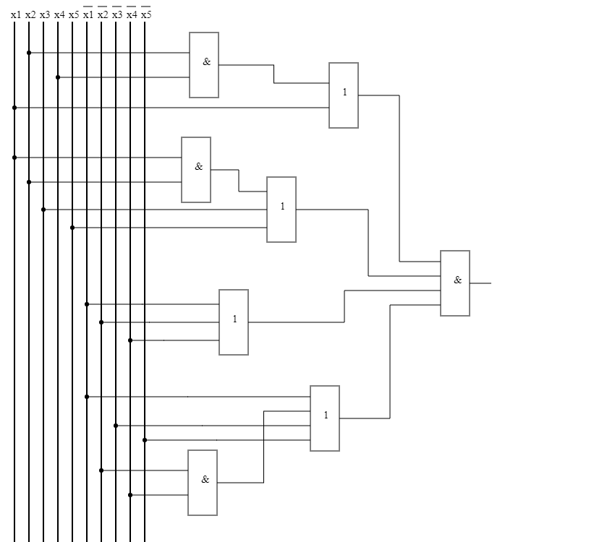

SQ=22 τ=3t

**Однофазные входы**

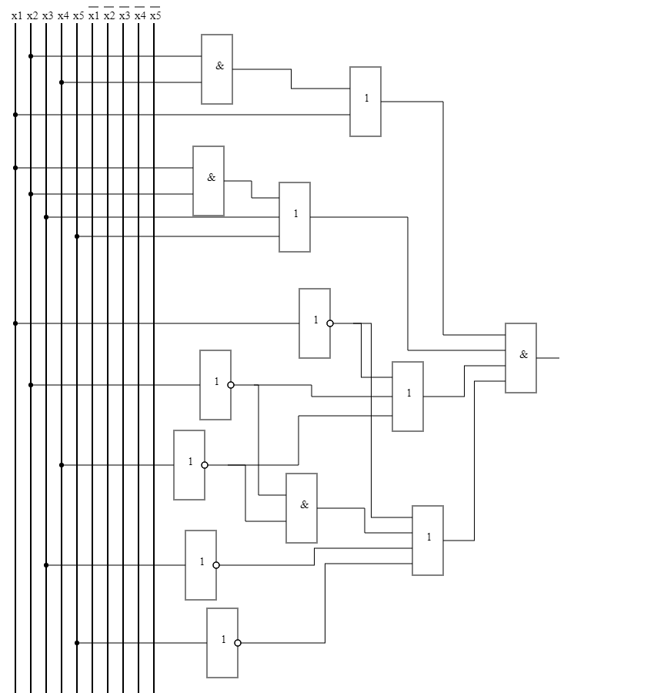

SQ=27 τ=4t

**Базис ИЛИ-НЕ**

(х1 ∨ x4x2) (х1x2 ∨ x3 ∨ x5) (х̄1 ∨ x̄2 ∨ x̄4) (х̄1 ∨ x̄4x̄2 ∨ x̄3 ∨ x̄5) =

=(х1 ↓ (x̄4↓x̄2)) ↓ ((х̄1 ↓ x̄2) ↓ x3 ↓ x5) ↓ (х̄1 ↓ x̄2 ↓ x̄4) ↓ (х̄1 ↓ (x2 ↓ x4) ↓ x̄3 ↓x̄5)

Проверка на наборах:

f(10000) = 0  
f(10001) = 1

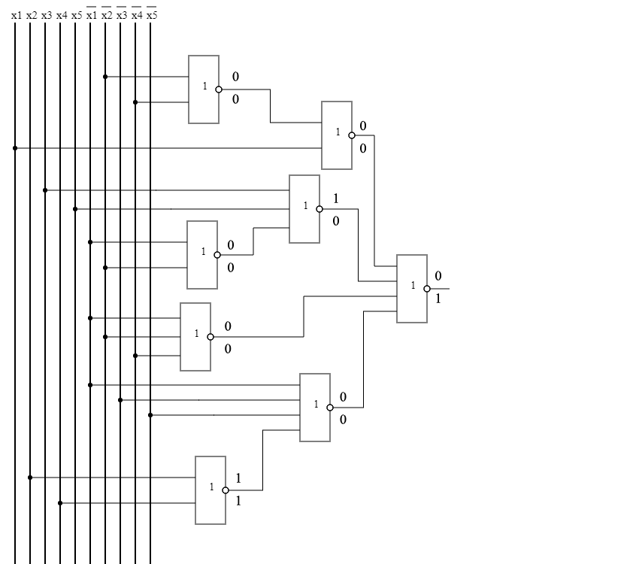  
  
  
  
  
  
  
  
  
  
  
  
  
  
  
  
  
  
  
  
  
  
  
  
  
  
  
  
SQ=22 τ=3t